Welcome!
Date
Name
Spouse
Address
City
State Zip _________
Email

Please Contact By
❑ Card  Phone  Visit

Telephone Best Time to Call
Home ______________
Work ______________

Guest: First Time Second Time
Are you a church member: yes no
Church
City, State

Circle Appropriate Age/Grade Group(s)
Preschool: Ages: B-1 2-3 4-5
Children: Grades: K 1 2 3 4 5 6
Youth: Grades: 7 8 9 10 11 12
Adults: Ages:18-29 30s 40s 50s 60s+

How did you learn about our church?
Newspaper Friend Yellow Pages Mail
Other

I am a guest of:

New in the Community? Yes No
Names & ages of children at home

Weekly Service & Activity Schedule

July 24, 2016

9:45 a.m. Sunday School
11:00 a.m. Worship Service
6:00 p.m. Evening Service

Week of July 24, 2016

Wednesday 6:30…………………………Meal/Bible Study
Thursday 10:00am…………………….Adult Fellowship

Upcoming Events
August
1-4…………………..……Pre Teen Camp (Highland Lakes)
11…………………………………………….Adult Fellowship
14……………………………………………Business Meeting
25…………………………………………….Adult Fellowship

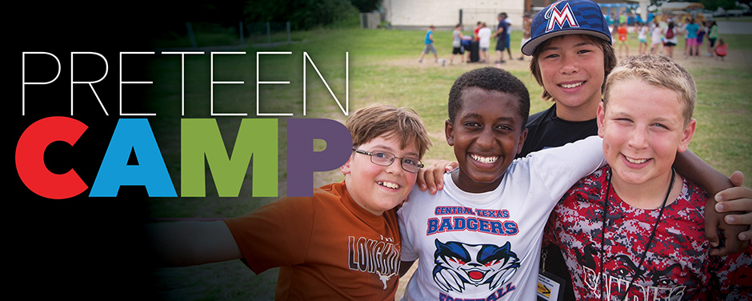
It’s never too late in begin praying for those who will be attending Preteen Camp Aug 1 – Aug 4. Pray God will reveal His many wonders and truths to these kids. Pray for safe travel. Wouldn’t hurt to pray for adults attending as well!

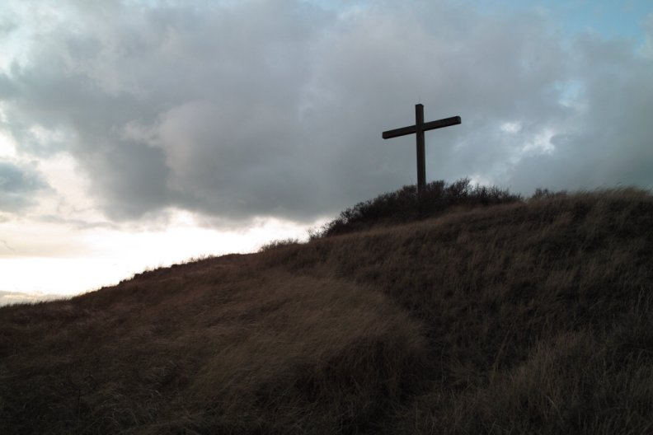

Knobbs Springs Baptist Church

July 24, 2016

Church Information:

KnobbsSpringsBC.com KnobbsSpringsBaptist@gmail.com

1662 CR 305, McDade, Texas 78650 512-273-2743

David Atwood, Pastor Cell 512-470-5098

Patti Radford, Office Manager Cell 512-968-7821

